Topic:TryHackMe: Cyber_Kill_Chain

Lab Overview
Platform: TryHackMe
Room:Cyber_Kill_Chain
Status: Completed

1. Introduction
In this section, I learned about the Cyber Kill Chain® framework, which was created by Lockheed Martin in 2011 based on the military concept of a kill chain.
The Cyber Kill Chain describes the different phases an attacker goes through during a cyber attack. Understanding these phases helps security professionals recognize attacks, understand an adversary's objectives, and identify where an attack can be stopped.
The seven attack phases covered in this room are:
- Reconnaissance
- Weaponization
- Delivery
- Exploitation
- Installation
- Command & Control
- Actions on Objectives
I also learned that the Cyber Kill Chain can help organizations understand security gaps and improve their security controls. For SOC Analysts, Security Researchers, Threat Hunters, and Incident Responders, understanding these phases helps in recognizing intrusion attempts and responding to attacks.

The question asked:
“Read the above.”
My answer was: Completed
Why: I read the introduction and understood the purpose, learning objectives, and seven phases of the Cyber Kill Chain framework.

2. Reconnaissance
In this section, I learned that Reconnaissance is the research and planning phase of a cyber attack. During this phase, an attacker gathers information about the target, such as infrastructure details, employee information, business processes, and exposed technologies.
A major part of reconnaissance is OSINT (Open-Source Intelligence), where publicly available information is collected from sources such as:
- Search engines
- Social media
- Online forums and blogs
- Public records
- WHOIS and technical information
I also learned about two types of reconnaissance:
- Passive Reconnaissance — gathering information without directly interacting with the target, such as WHOIS lookups and reviewing public information.
- Active Reconnaissance — directly interacting with the target, such as port scanning, banner grabbing, or probing open services.
Another important concept was email harvesting, which is the process of obtaining email addresses from public, paid, or free services. Attackers can use these addresses for phishing and other social-engineering attacks.

Questions and Answers
1. What is the name of the Intel Gathering Tool that is a web-based interface to the common tools and resources for open-source intelligence?
My answer was: OSINT Framework
Why: The OSINT Framework is described in the room as a collection of OSINT tools organized into different categories and provides a web-based interface for finding these resources.

2. What is the definition for the email gathering process during the stage of reconnaissance?
My answer was: Email harvesting
Why: Email harvesting is the process of obtaining email addresses from public, paid, or free services. An attacker can use the collected addresses for phishing attacks.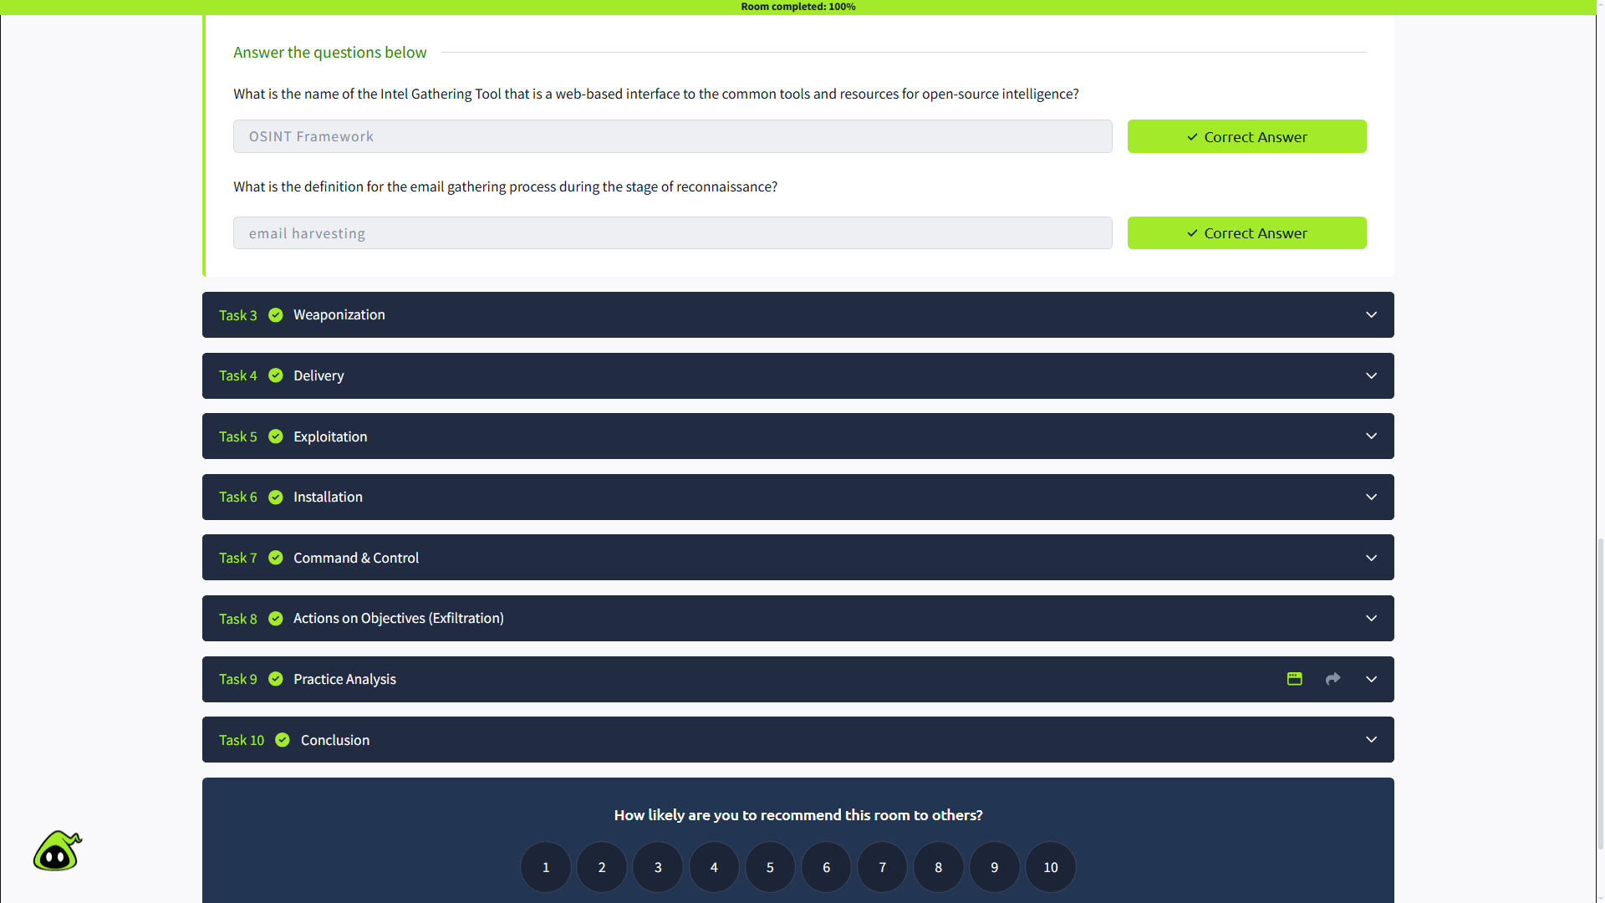

3. Weaponization
In this section, I learned that Weaponization is the phase where an attacker takes the information gathered during reconnaissance and turns it into tools or payloads that can be used in an attack.
I learned some important terms:
- Malware — software designed to damage, disrupt, or gain unauthorized access to a computer.
- Exploit — code or a program that takes advantage of a vulnerability or flaw.
- Payload — malicious code that an attacker runs on a victim's system.
During this phase, attackers may create malicious Microsoft Office documents, develop malicious payloads, set up Command and Control (C2) infrastructure, create backdoors, or design convincing phishing templates.

The question asked:
“What is the term for automated scripts embedded in Microsoft Office documents that can be used to perform tasks or exploited by attackers for malicious purposes?”
My answer was: Macros
Why: The section explains that attackers can create infected Microsoft Office documents containing malicious macros or VBA (Visual Basic for Applications) scripts.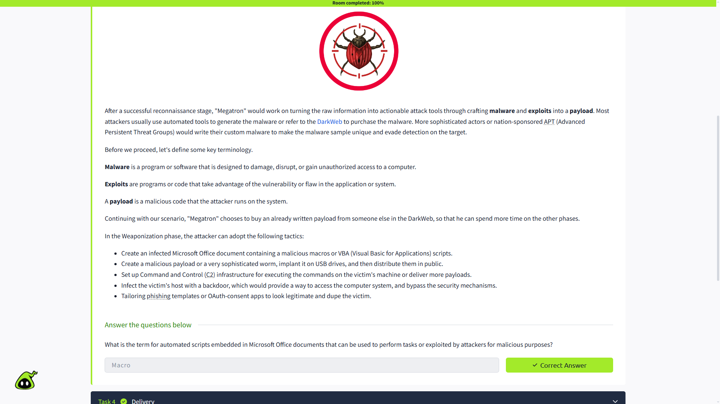

4. Delivery
In this section, I learned that Delivery is the phase where the attacker chooses how to transmit the malware or payload to the target environment.
The room covered three common delivery methods:
- Phishing email — sending a malicious link or attachment to a specific person or multiple people.
- USB Drop Attack — leaving or sending infected USB devices so that the target uses them.
- Watering Hole Attack — compromising a website that a specific group frequently visits and redirecting or exposing visitors to malicious content.
I learned that a watering hole attack can result in a drive-by download, where the victim unintentionally downloads malware or a malicious application.

The question asked:
“What do you call an attack targeting a specific group by infecting their frequently visited website?”
My answer was: Watering Hole Attack
Why: A watering hole attack targets a specific group by compromising a website that the group commonly visits, with the goal of delivering malicious content to the victims.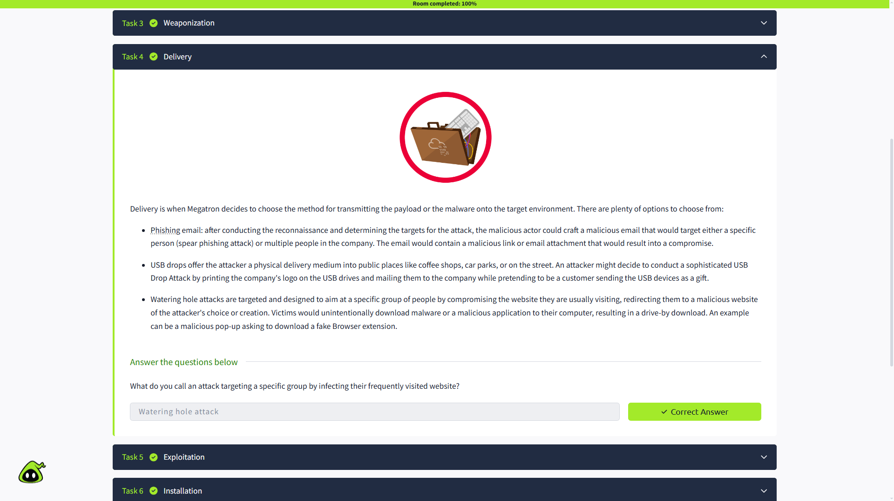

5. Exploitation
In this section, I learned that Exploitation is the stage where the attacker's code executes on the target by taking advantage of a vulnerability.
The room covered several techniques that attackers can use:
- Malicious Macro Execution — malicious macros delivered through documents can execute harmful code.
- Zero-Day Exploits — exploit unknown and unpatched vulnerabilities.
- Known CVEs — exploit publicly known vulnerabilities that have not been patched.
After gaining access, an attacker may also exploit vulnerabilities to escalate privileges or move laterally through the network.
Some signs of exploitation that a security analyst can look for include:
- Unexpected process creation
- Registry changes or new services
- Suspicious command-line arguments in system logs

The question asked:
“What is the term for a cyber attack that exploits a software vulnerability that is unknown by software vendors?”
My answer was: Zero-Day Exploit
Why: A zero-day exploit takes advantage of a vulnerability that is unknown to the software vendor and therefore has not yet been patched.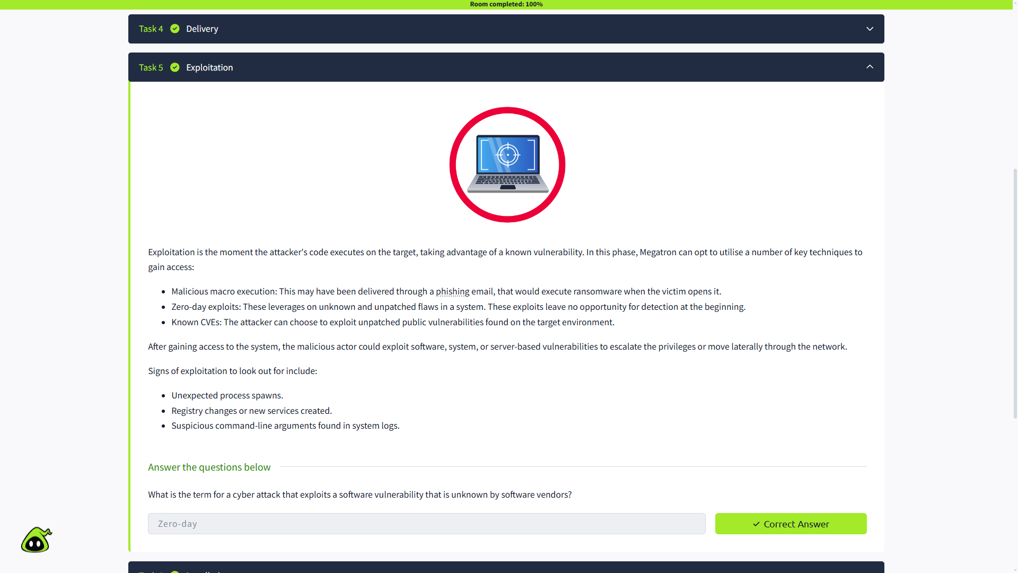

6. Installation
In this section, I learned that Installation is the phase where an attacker establishes a way to maintain access to a compromised system.
A backdoor provides an access point that can allow an attacker to reconnect to a compromised system. If the initial access is removed or the system is patched, an attacker may use a persistent backdoor to maintain access.
The room covered several persistence techniques, including:
- Installing a web shell on a web server
- Installing a backdoor on the victim's machine
- Creating or modifying Windows services
- Adding malicious entries to Registry Run Keys or the Startup Folder
I also learned about timestomping, where an attacker modifies file timestamps to make malicious files appear legitimate or avoid detection during forensic investigation.

Questions and Answers
1. What technique is used to modify file time attributes to hide new or changes to existing files?
My answer was: Timestomping
Why: Timestomping allows an attacker to modify file timestamps, including created, accessed, and modified times, to make changes harder to detect.

2. What malicious script can be planted by an attacker on the web server to maintain access to the compromised system and enables the web server to be accessed remotely?
My answer was: Web Shell
Why: A web shell is a malicious script placed on a web server that allows an attacker to maintain access and interact with the compromised system remotely.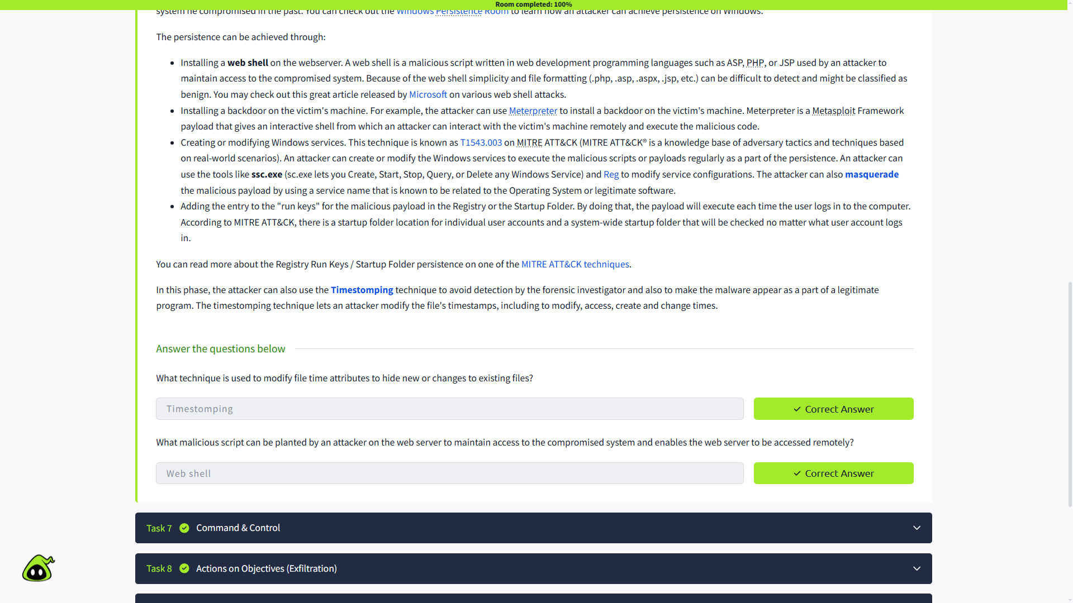

7. Command & Control
In this section, I learned about Command & Control (C2) communication. After gaining persistence and executing malware, an attacker can establish a C2 channel to remotely control and manipulate the compromised machine.
The infected host communicates with an external server controlled by the attacker. This communication is also called C2 Beaconing, because the infected system regularly communicates with the C2 server.
The room covered common C2 channels such as:
- HTTP — port 80
- HTTPS — port 443
- DNS — can be used for DNS tunneling
HTTP and HTTPS traffic can blend with legitimate web traffic, while DNS-based C2 involves the infected machine making repeated DNS requests to an attacker-controlled DNS server or domain.

The question asked:
“What is the C2 communication where the victim makes regular DNS requests to a DNS server and domain which belong to an attacker?”
My answer was: DNS Tunneling
Why: The room describes this type of C2 communication as DNS Tunneling, where the infected machine makes constant DNS requests to a DNS server controlled by the attacker.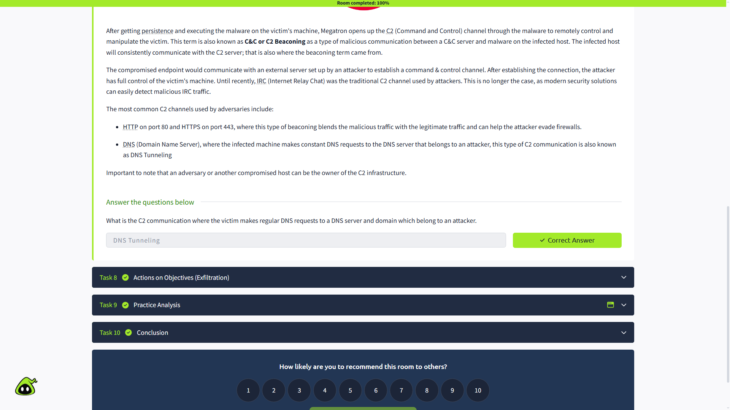

8. Actions on Objectives (Exfiltration)
In this section, I learned that Actions on Objectives is the final phase of the Cyber Kill Chain. After completing the earlier phases, the attacker can finally carry out their original goals on the compromised system or network.
The room covered several actions an attacker may perform, including:
- Collecting user credentials
- Performing privilege escalation
- Conducting internal reconnaissance
- Moving laterally through the environment
- Collecting and exfiltrating sensitive data
- Deleting backups and shadow copies
- Overwriting or corrupting data
I also learned about Shadow Copy, a Microsoft Windows technology that can create backup copies or snapshots of files and volumes, even while they are in use.

The question asked:
“What technology is included in Microsoft Windows that can create backup copies or snapshots of files or volumes on the computer, even when they are in use?”
My answer was: Shadow Copy
Why: The section specifically describes Shadow Copy as a Microsoft technology that creates backup copies or snapshots of computer files or volumes, including files that are currently in use.
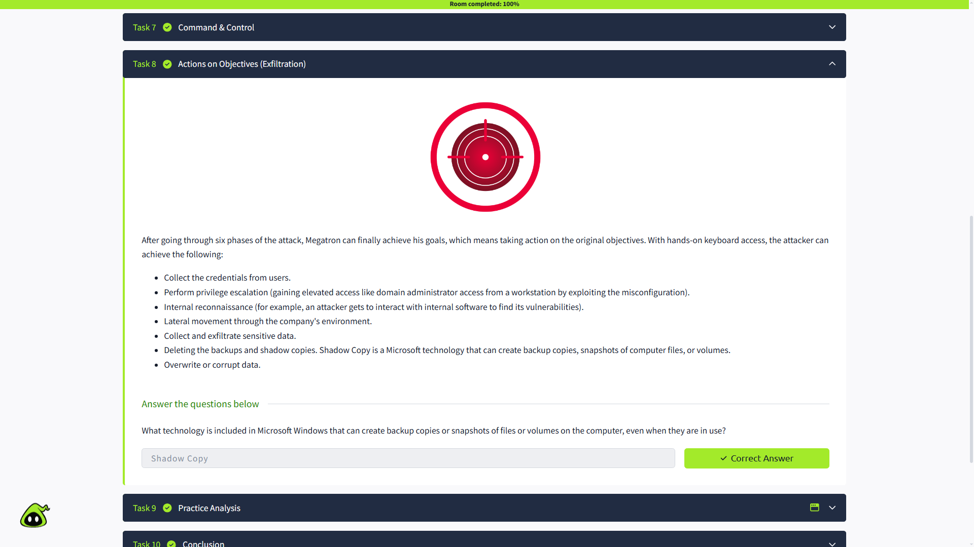

9. Conclusion
In this section, I learned that the Cyber Kill Chain can be useful for improving network defence, but it is not a perfect framework and should not be used as the only security model.
The traditional Lockheed Martin Cyber Kill Chain was established in 2011 and has not received major updates. Modern attackers use different TTPs (Tactics, Techniques, and Procedures) and can change indicators such as file hashes and IP addresses to avoid detection.
I also learned that the traditional Cyber Kill Chain mainly focuses on malware delivery and network security, so it has limitations when dealing with threats such as Insider Threats.
The room recommends using other frameworks alongside the traditional Cyber Kill Chain, including:
- MITRE ATT&CK
- Unified Kill Chain
Using multiple frameworks can provide a more comprehensive approach to understanding and defending against modern cyber attacks.
: Completed
Why: I read the conclusion and understood the advantages and limitations of the traditional Cyber Kill Chain framework.
